ColoRacing

Design Document

Table des matières

I. ColoRacing 3

A. Overview 3

B. Vision Statement 3

II. Story 3

III. Core Gameplay 3

A. Spirit 3

B. Color 3

IV. Environment 4

A. Wall 4

B. Bonus and Malus 4

C. Black hole 5

V. Structure 5

A. Launch a game 5

B. Join a game 5

C. Winning condition 5

# ColoRacing

## Overview

ColoRacing is a racing game, using color applied on the map by players, in successive rounds to determine the winner. Multiple bonus and malus will be available to be the first and to apply the most of the player own color during the race.

## Vision Statement

The player should be delivered the following experiences:

* Effortless play
* Unique experience
* Friendly gaming

# Story

You are controlling a color spirit before the big bang happened. The winner of the race will be the next spirit to be allowed to create his own universe. Each color has an associated feeling, so the resulted universe will be filled in majority with this color and feeling.

# Core Gameplay

## Overview

A player is a ball of color called “spirit”. It’s a multiplayer game from 2 to 4 players.

The map is a big open space where players can go anywhere they want. The size can be chosen before the race start.

Players will begin the race at random places and each round the places will be different.

A race is composed of 5 minimum rounds, but it can be changed by players before the game.

## Spirit

The spirit is controlled by the player. It can move forward, backward, and turn to the left and to the right. He cannot go through the wall but he can go through other players.

|  |  |
| --- | --- |
| Action | Keyboard |
| Forward | z |
| Backward | s |
| Left | q |
| Right | d |

## Color

The player leaves behind the spirit a trail of the color of the spirit. This trail stays during the entire game.

If a player goes on a trail of his own color, he gains a speed bonus depending on the percentage of his color on the position of the spirit during the whole time the spirit is located on his color.

If a player goes on a trail of another player’s color, he lose as many speed as the percentage of color from other players.

Every time a player goes on a square, he put his color on it (10%). If there is already a color, the square is in the color of the mix of all color in the square (depending on the percentages of each color on the square). If the quantities of colors on a square are already at 100%, the colors of others player will be decrease by 20% each.

# Environment

## Wall

The wall is an inanimate object. At the beginning of a round, walls will be disposing randomly into the map and will change in every round. A wall could have different lengths but have always the same height and width. A spirit cannot go through a wall except with a certain kind of bonus.

## Fog

The outlook of a player is very limited because of the Fog. The density of the fog can be change with bonus or malus.

## Bonus and Malus

In the map will be dispose randomly some mystery square. These squares can add a bonus or a malus to the player when the spirit goes on it.

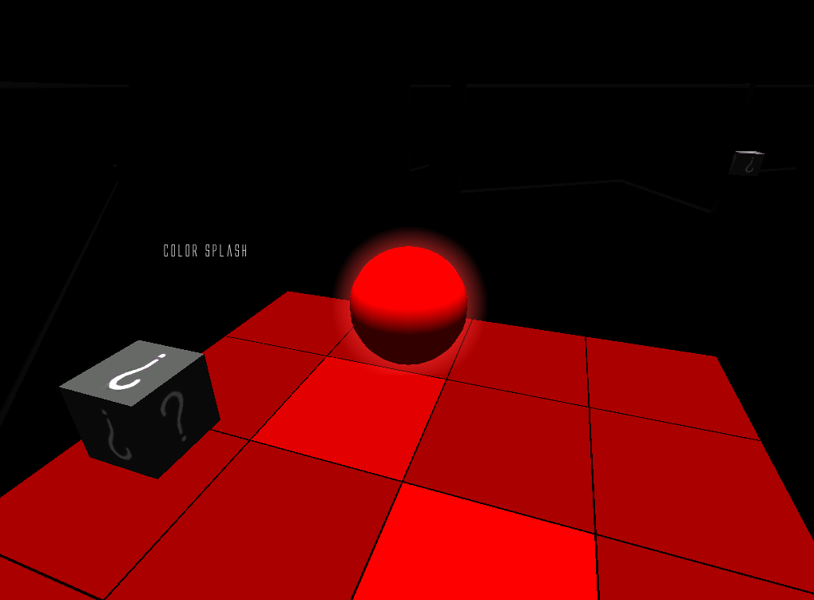

The player just goes on a color splash bonus.

## Black hole

Black holes are randomly disposed on the map at the beginning of each round. Black hole permit to player to be teleport randomly into another black hole on the map. So it can be a shortcut or a Detour.

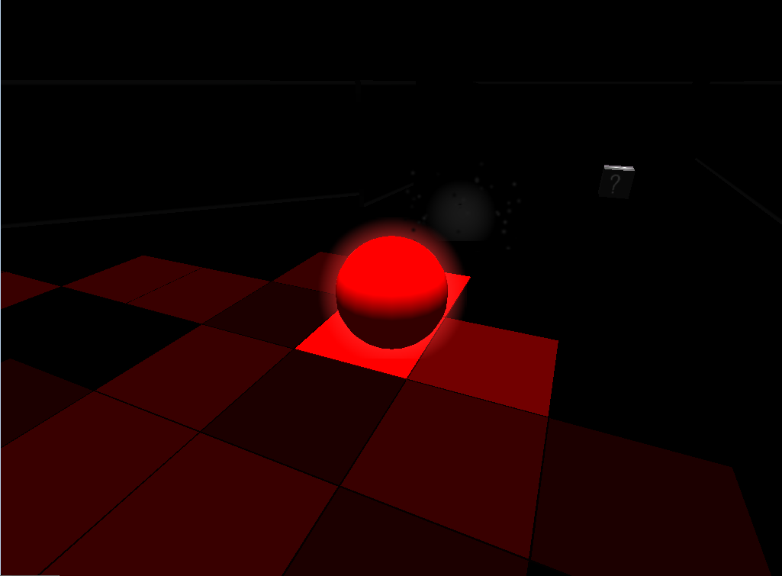

# Structure

## Launch a game

To launch a game, you just have to click on “Create a game” on the Menu. Your computer will then be used as a server for all the player of the game. Then, wait for other players.

## Join a game

To join a game, you have to enter the IP address of the player who creates the game in the appropriate field. Then click on “Join a game”.

## Winning condition

To win the game, you should have the best score of all the players in the game at the end of the final round. To increase your score, you should color the map and/or be the first at the finish point. 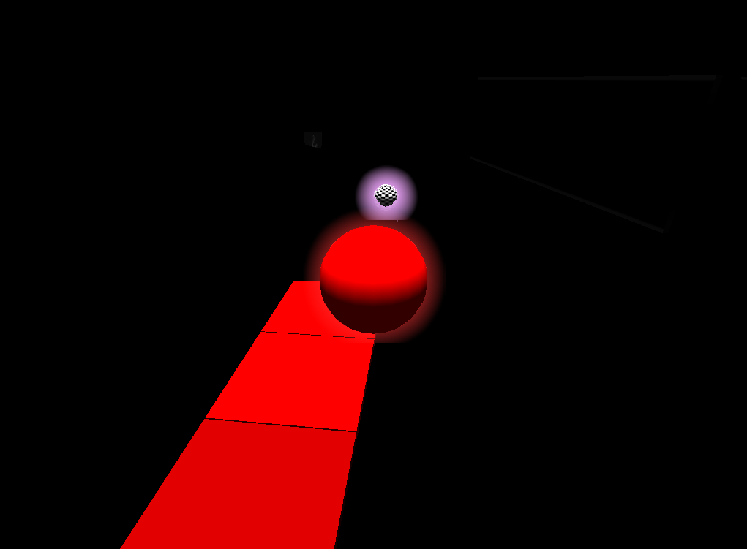

A spirit near a finish point.

# Target audience

It’s a game for everyone because like a lot of racing game, it’s nonviolent and playable by a lot of person whether people less than 10 years old or more than 60.